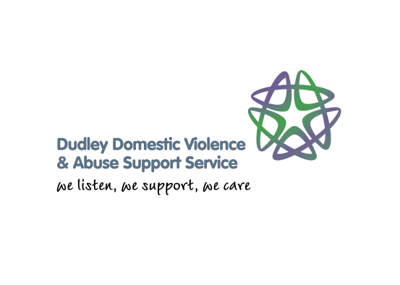

Community Champion Volunteering Project

The Dudley Community Champion Project was established in March 2015. The project aimed to raise awareness in the community about domestic violence and abuse, engage with the community about their experiences and involve them in service delivery and development. In the first six months of the project we have held 8 community training days raising awareness of domestic violence in Dudley and trained 51 volunteers. The training days provide information to volunteers about domestic violence and abuse, honour based violence, forced marriage, female genital mutilation, local service provision for victims, effective safety planning and how to refer victims into appropriate support. Once trained, volunteers can choose to take the learning back to their area of work/ back into the community, volunteer in services, and/ or assist in the delivery of training programs to other volunteers and professionals. They also have the opportunity to join a Survivor’s Group that provides peer support and consultation through service user involvement.

We have run awareness raising sessions across the borough in a variety of locations: Mummy Mornings at Merry Hill, Church Tea Dances, Breastfeeding Groups, Health Champions Groups, Home-Start projects, libraries and voluntary sector organisations. There have been over 200 attendees at these sessions, who have provided feedback such as:

It was inspirational and life changing. I’m truly grateful for the organisers. Please keep up the good work!
Brilliant! Information was fantastically put across and interesting, also a chance to say what happened to me. Thank you!
Extremely detailed discussion, gained a lot of knowledge nice hearing varied opinions and experiences
Fantastic training course, would be great to be involved in more projects regarding domestic violence
The project was initially funded for one year through the People’s Postcode Lottery. It has been hugely successful and we are working on plans to fund it through community fundraising next year. The Survivor’s Group are keen to generate funding around community based events and sponsored activities and will be fully supported by Sandwell Women’s Aid and Dudley Safe and Sound to achieve this. The survivors of domestic abuse involved with the project feel that to fund it themselves would not only be hugely empowering, but would also give a message of hope and strength to victims who are still experiencing domestic violence and abuse.

